INFORMATION
HANDBOOK
2024
Table of Contents

Page

MAZENOD COLLEGE 3

GENERAL 4
- Eugene De Mazenod – The Man

COLLEGE AIMS, DISCIPLINE AND PASTORAL CARE 5-7
- Faith
- Academic
- Community
- Personal Development
- Pastoral Care at Mazenod College

STUDENT PROTECTION, SAFETY AND WELLBEING…………………………………………7
- Student Code of Conduct …………………………………………………………..…………. 8
- Behaviour policy…………………………………………………………………………….. 8-10

PARENT / TEACHER CONTACT 11

RELIGIOUS LIFE 11

INTELLECTUAL FORMATION 11

HOMEWORK 12

SPORT 12

UNIFORM 13-14

ADMINISTRATIVE DETAILS
- VISITORS TO THE COLLEGE 14
- PARENTS ASSOCIATION 14
- NEWSLETTER 14
- TELEPHONE CALLS AND MESSAGES 14
- MOBILE PHONES 14
- LOCKERS / LOCKS 14
- BAGS 14
- DAILY ROUTINE…………………………………………………………………………………15

TRANSPORT 16

COLLEGE PRAYER and ANTHEM 17

ST EUGENE DE MAZENOD – KEY VALUES 18

MAZENOD COLLEGE

INFORMATION HANDBOOK

The dream of establishing a College for boys in the Hills first came to light in 1963 at the Lourdes Monastery, Lesmurdie, when the Oblate Provincial, Fr. Cagney, O.M.I. and Fr. D. McCarthy, O.M.I., met with Mr. Dunn the local Member of Parliament and Real Estate Agents. He placed before the priests a map of the Hills district and on it was a block set aside for 'Education Endowment.'

After much discussion and indeed detailed negotiation, both with the State Government and Kalamunda Shire Council, Deeds of the Land were promised on 27th January 1965 providing the Oblates could start a building and classes within two years. Finance then had to be sought.

Land began to be cleared in May of 1965 and the foundations for the first building were laid towards the end of September. This building was completed, later than expected, in the first week of May 1966.

The 14th February 1966 saw Fr. Denis McCarthy, O.M.I. and Fr. Ian Mackintosh, O.M.I. welcome thirty-one students to be the inaugural classes of Grades 6 and 7 at Mazenod Western Australia. Fr. Don Hughes, O.M.I. appointed as the first Rector of the College, arrived shortly before Easter, 1966 and on the 8th May, the official opening of the First Wing took place.

The dream of the Oblates to serve the people of Western Australia through education was fully realised when a boarding residence was established in 1967, thus enabling students from remote areas to receive a Catholic education in the Oblate tradition.

There are eight Rectors and one Principal who have served the College:

Fr. Don Hughes, O.M.I. - 1966 - 1972
Fr. Ian Mackintosh, O.M.I. - 1973 - 1977
Fr. Michael McMahon, O.M.I. - 1978 - 1980
Fr. John Cranley, O.M.I. - 1981 - 1986
Fr. Patrick Dwyer, O.M.I. - 1987 - 1992
Fr. Peter Daly, O.M.I. - 1993 - 2001
Fr Kevin Davine, O.M.I. - 2002 - 2004
Fr Brian Maher, O.M.I - 2005 - 2013
Fr Peter Daly O.M.I. - 2014 - 2015
Mr John Payne - 2016 - 2016
Mr Andrew Watson - 2017 – 2023 (Term 1)
Mr Simon Harvey - 2023 (Term 2) -

College Motto: FIDEM PATRIAMQUE SERVABO

(I will serve God and my Country)

GENERAL

Mazenod College is conducted by the Oblates of Mary Immaculate, a Missionary Order founded in France in 1818 by Bishop Eugene de Mazenod, after whom the College is named. In Australia, the Oblate Fathers conduct three Colleges, Mazenod Melbourne and Iona College in Brisbane, each catering for over 1,000 boys and Mazenod Lesmurdie with an enrolment of around 500, eighty of whom are boarders. Mazenod (WA) was founded in 1966.

EUGENE DE MAZENOD - THE MAN

Eugene De Mazenod was born on August 1st, 1782 at Aix-en-Provence, France, on the eve of the French Revolution. Coming from a family of wealth and nobility, young Eugene was forced to flee his native France at the tender age of eight, under the threat of evacuation by revolutionaries who were intent on destroying the last remnants of the aristocracy in the New Republic.
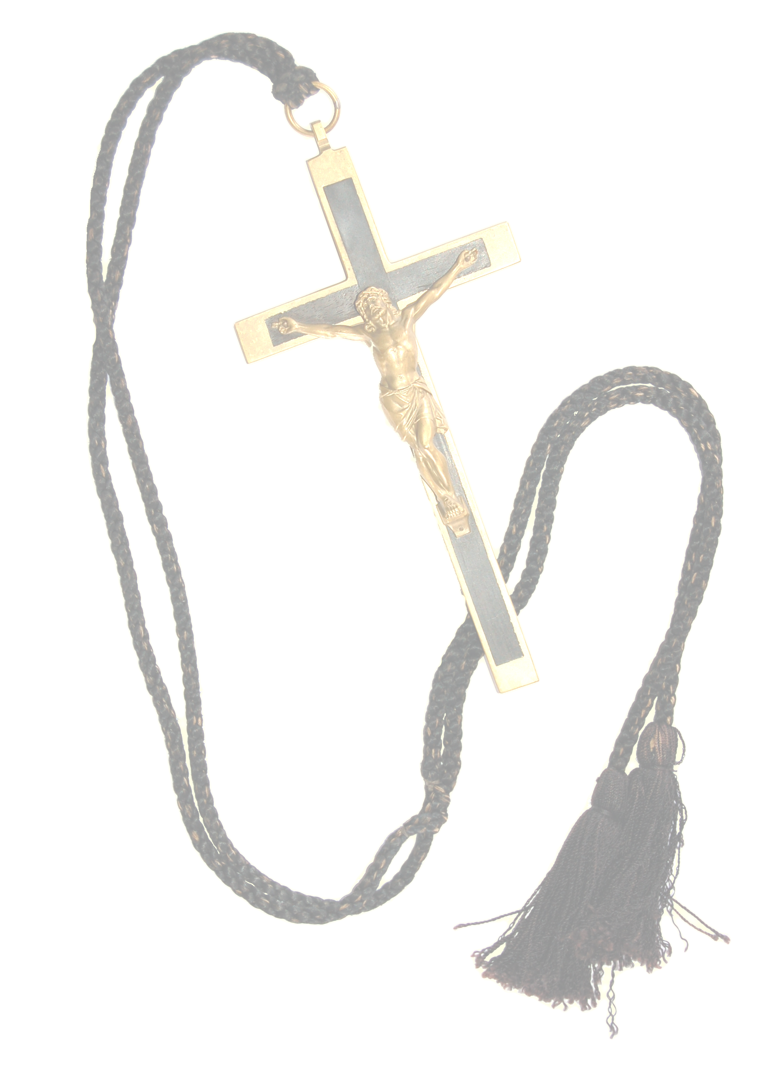

For eleven years, De Mazenod lived as a political refugee, moving throughout Italy, trying to keep up his education and planning for the day when he might return to restore the family fortunes. It was during these turbulent times that Eugene received the powerful faith influence of a family in Venice, the Zinellis, to whom he later ascribed his vocation to be a priest. It was also a time of great temptation, where in places like Palermo, the young 20-year-old got caught up in the luxury and “fast lane” lifestyle of the Nobles’ Court.

Like many young adults, De Mazenod had some profound choices put before him. When he finally decided it was safe to return to Provence, he had decided to marry back into money and revive the family fortunes. Thus, he could play out his proper role in society as a powerful aristocrat.

Eugene felt a deep sense of dissatisfaction pursuing his worldly ambition - that restlessness that has led many, before and since, to the brink of a decision. For De Mazenod, it brought him on Good Friday, 1807, to the foot of a crucifix, where he was overwhelmed by Jesus’ love and self-sacrifice. This was the moment that changed his life. The following year, he entered the seminary of St. Sulpice, in Paris, and he had a very clear ideal:

.....he would be the servant and priest of the poor, to restore the
Church so ravaged by the revolution....

When Eugene was ordained to the priesthood in 1811, his Bishop was faced with the dilemma of what to do with his young aristocrat, “so personal and impetuous”. He was somewhat relieved when Eugene asked to work with the poor and abandoned of the cities and outlying villages. The young Father De Mazenod also turned his efforts towards youth, founding an association of some 300 who were to share in his mission to the poor, which included an outreach to prisoners, casualties of the Napoleonic wars and a typhus plague.

By 1815, Eugene realised his overwhelming ambition to serve would not be accomplished, unless he drew others to his cause, to share a common life, and be united by religious vows. On January 26, 1816, Fr De Mazenod and four friends dedicated their lives to bringing the Good News to the Poor in this way. Their new group was approved by Pope Leo XII on February 17th, 1826, and took the name of the Oblates of Mary Immaculate.

At the time of his death in 1861, the Oblate Congregation numbered 417 men. When, on December 3rd 1995, Pope John Paul II canonised Eugene De Mazenod, there were over 6000 Oblates, spreading the Gospel in nearly 60 countries across the globe. His sons, and the Churches they serve, continue to be the clearest sign of the continuing relevance of the Oblate Missionary call, to serve the poor and the most abandoned.

COLLEGE AIMS, DISCIPLINE and PASTORAL CARE

The Aims and Objectives of Mazenod are those of a community growing together in a faith relationship with Christ, transmitting Christian values and thus forming a part of the saving mission of the Catholic Church. It is a place where human knowledge, enlightened and enlivened by faith is shared by teacher, students and parents, in a spirit of love and freedom. Mazenod is a place of integral formation by means of a systematic and critical assimilation of local, national and world culture.

Individual subjects contribute in their own particular methods to the students' total growth. They enable the pupils to assimilate skills, knowledge, intellectual methods and moral and social attitudes, all of which help to develop each pupil’s personality and lead him to take his place as an active member of the community of man. The aim of each subject is not merely the attainment of knowledge but the acquisition of values and the discovery of truth.

Mazenod seeks to provide the means by which the full potential of each of its students and that of the school community is realised. These are presented under the following headings:

 | 1. FAITH | 3. COMMUNITY | 5. PASTORAL CARE
 | 2. ACADEMIC | 4. PERSONAL DEVELOPMENT

1. FAITH: Aims and Objectives
The aim is the teaching of the gospel of Christ and transmission of the Catholic heritage, fostering through prayer, liturgy and sacramental life, a total commitment of one’s whole being to the person of Christ in the Church.

- Mazenod seeks to foster in all its students a development of their knowledge and love of God through a deepening their faith in Jesus Christ.
- Mazenod seeks to develop persons who are responsible and inner-directed, capable of choosing freely in conformity with a well-informed conscience.
- Mazenod seeks to promote a moral consciousness in its students, in accordance with Christ’s teaching and the mind of the Church, and to enable them to relate it to their own lives.
- Mazenod seeks to provide a suitable Christian atmosphere which encourages the growth of the whole person, providing the opportunity to integrate culture and faith through the acceptance of Christ and his ideas, attitudes and values.
- Mazenod seeks to provide a critical and systematic account of the teaching of the Gospel and the Catholic Church in accordance with guidelines provided by the Archdiocese whilst at the same time enabling students to experience a sense of Christian Community.

2. ACADEMIC: Aims and Objectives
Knowledge is a means to self-fulfilment, material prosperity and success, but it is also and especially a call to serve and be responsible for others. This implies the following objectives:
- to ensure that all its students attain the highest level of literacy, oracy and numeracy appropriate to their level of ability
- to respect students of all ability and to cultivate their abilities to the fullest, whilst also responding to excellence and ability in other students
- to foster the natural creative talents of its students developing creative and imaginative ways of thinking
- that Mazenod has provision for a wide range of sporting and physical activities as well as an awareness of the importance of physical fitness and good nutrition as significant elements in healthy living
- that Mazenod will develop skills of analytical and critical thought, and emphasise the value of learning as an ongoing factor in self-development throughout life. This requires the promotion of good study methods in order that students’ full potential be realised
- that Mazenod will provide suitable guidance to students in subject selection throughout their school life and especially adequate career guidance
- that Mazenod, particularly in its teaching of the humanities subjects, promote an appreciation of Australia’s culture and history as well as those of other societies and systems.

3. COMMUNITY: Aims and Objectives
Mazenod sees itself as being a community co-operating together, witnessing to the Gospel values and responding to a call to service and responsibility to others.

This means we engage in the:
- provision of pastoral care to the individual student
- cultivation of a friendly and caring atmosphere
- cultivation of community by maximising personal communication between staff and students and among staff, students and parents
- development of an attitude of cooperation with, and sense of belonging not only to the school community but also to related community groups. This includes involvement with wider and different community groups, e.g. parish, local social organisations and organisations with different concerns such as Freedom from Hunger; St. Vincent de Paul Society, etc
- promotion within Mazenod’s community of an appreciation of the family as the basic unit of society, as the source of its being and that in responding to each student, we respond to this basic community
- cultivation of loyalty and solidarity of students towards the College.

4. PERSONAL DEVELOPMENT: Aims and Objectives
Mazenod College is committed to the development of the whole person, since in Christ, the perfect human, all human values find their fulfilment and unity.

This implies the following objectives:

- To develop the individual character and personality of each student, his sense of dignity and self-worth by promoting in each student
  - self-reliance and self-discipline
  - personal initiative and capacity for leadership
  - reliability, honesty and integrity

- To promote in each of its students:
  - tolerance and respect for others and others’ opinions, beliefs and cultures and especially those of their fellow-students who come from diverse cultural backgrounds
  - sensitivity to other people’s needs, and respect for their rights and property
  - responsiveness to the call from every part of the world for a more just society
  - an appreciation in students of their total physical, cultural and spiritual environment with its accompanying responsibility to safeguard and promote it.

    - PASTORAL CARE AT MAZENOD COLLEGE
The aim of the pastoral care structures at Mazenod is to support each student in developing socially, academically and physically as a member of both the College community as well as the wider community in which they live.

The Heads of Year, Form Teachers, Heads of Learning, Psychologists, support teachers and class teachers all work together to provide assistance and guidance for each student in recognising effort and success and modifying inappropriate behaviour.

Success and effort are recognised through a variety of means, depending on the year group and circumstances. This recognition may take the form of:

- presentation of certificates and awards at year or whole school assemblies
- letters or postcards sent to parents
- awarding of stickers for academic or behavioural effort or success
- selection for leadership positions such as Form Representative, Student Councillor, Peer Support Leader, House leader, Prefect
- invitation to special events
- awarding of scholarships
- awards at the Annual Presentation night
- an interview with Deputy Principal or Principal.

An important part of any Pastoral Care structure is the monitoring and modification of inappropriate behaviour. A crucial aspect of educating our boys is to help them to make wise choices in life and for them to understand that the choices they make have consequences for both themselves and the communities in which they live. This process needs both the College and parents working together to be successful.

In order to help our boys, make good decisions, we clearly articulate the College’s expectations in regard to effort, behaviour and grooming. When a student fails to meet these expectations, a process is followed to help the student identify the inappropriate choices and behaviour and to make the necessary changes for the future. This process will include a range of consequences depending on the seriousness of the behaviour and a student’s previous behaviour.

STUDENT PROTECTION, SAFETY AND WELLBEING
At Mazenod we hold the care, safety and well-being of students as a central and fundamental responsibility of our organisation. All students have a right to be safe and feel safe, and we commit to ensure and protect these rights in all aspects of our community and programs.
Mazenod is a Christ centred and child focused place of learning and enacts the Church’s commitment to the dignity of the individual. All members of our College have a fundamental right to be treated with respect, and to learn and teach in a safe and supportive environment.
We demonstrate this commitment through the implementation of comprehensive Student Protection, Student Safety and Student Wellbeing policies and procedures to keep all students, including our boarders, safe from harm.
The Pastoral Care Program, Student Code of Conduct, Productive Classroom, Behaviour Policy and Student Voice are key areas through which the College maintains a positive school environment and manages student behaviour and discipline.

STUDENT CODE OF CONDUCT
Mazenod College holds the care, safety and well-being of students as a central and fundamental responsibility of our organisation. Students have a right to be and feel safe, and the College commits to ensuring and protecting these rights in all aspects of our community and programs. Students also have the responsibility of being accountable for any behaviour that may put at risk the health, safety and wellbeing of themselves or others.

Students have the right to feel:
- safe - from verbal, physical, emotional, social, psychological harm
- included
- challenged and encouraged
- respected
- happy
- proud of our College.

Students have a responsibility to:
  - lead by example
  - follow the Productive Classroom and College rules
  - treat others with respect, courtesy and kindness
  - encourage and support positive behaviours, and refrain from harmful behaviours
  - bring positive conversations to our gatherings and assemblies
  - uphold the College Values so as to create an inclusive College community
  - tell someone in authority when safety is a concern.

As a member of Mazenod College, students hold a representative position of trust and accountability for their actions. The consequences of a breach of the student Code of Conduct will be determined by the Principle through the use of the Behaviour Policy.

BEHAVIOUR POLICY
Mazenod College is committed to enabling students to fulfil their potential in their social, physical, intellectual, emotional and spiritual development. The Behaviour Policy (available on the College website) includes strategies to:
  - maintain a positive school environment
  - promote effort
  - encourage positive behaviours and personal excellence
  - have students take personal responsibility for their actions
  - respond in a timely manner to negative behaviours.
Inappropriate behaviour can be separated into:

Minor breaches, which include but are not limited to: punctuality, dress, hair, litter, disruption in class, being in out of bounds areas, eating in class, inappropriate language, chewing gum, use of student personal devices during school hours, and breaches of other rules outlined in the Diary

Serious breaches, which include but are not limited to: physical violence, vandalism, insolence, confrontation, smoking, drinking, non-medical drugs (possession, use or trade), pornography, theft, bringing the College into disrepute, truancy, breaches of privacy through use of mobile phones/cameras/video, refusal to cooperate with the College, bullying, inappropriate use of the internet or other breaches to the ICT Use Agreement, bringing prohibited items to school, repeated minor breaches.

Please note, in particular, the College’s expectations in regard to the following:

(i) Attendance, Absences, Notes and Appointments:
Regular attendance at school is vital for success at school� Absences from school should be rare and necessary. When a student is absent from school, sport or school event notification should be given, where possible, in advance in writing. If this not possible there must be notification by phone or email on the day.
If notice is given by phone then a note or email must be provided by the following day.
Parental contact must be made with the College administration staff prior to 8:30am notifying the school of student absence. Contact can be made by phone on 9291 1500 or by email absentees@mazenod.wa.edu.au. Parents may wish to copy the appropriate Head of Year and/or Form teacher into the email. Staff can be emailed using surname.firstname@mazenod.wa.edu.au format.
When parental contact is not made, a SMS message will be sent to the parent’s mobile phone requesting confirmation of a student’s absence. A reason must be provided for all unexplained absences. When a student has accumulated multiple absence days (explained or unexplained), formal contact will be made with parents to outline the educational risk of repeated absences from school and, where necessary, implement strategies to restore satisfactory attendance.
In the case of absence on the day of an assessment or an assignment being due parental contact must be made, via the office, with the teacher of the affected assessment on the day. Please refer to the Assessment Policy on page 24a-26a.
If a student is absent from school on the day of a sporting or social event the student may not attend that event. College events such as athletics and swimming carnivals, MMD are compulsory school days, all students are expected to attend.
If students are absent from school for reasons other than medical, in particular family holidays, then it is the student’s responsibility to find out what work is to be missed and to ensure that they keep up to date.
Teachers will not be expected to set work for absences other than medical reasons.

(ii) Hairstyles: Hair is to be short and neat. It must be trimmed the same length on the sides and back, be off the ears and above the collar and eyebrows. Shaves of less than 3 are not permitted. Extreme styles such as (but not limited to) mullets, undercuts and fades are not permitted.
Students who do not meet the College requirements in regard to uniform and hair will be given a reasonable timeframe to remedy the discrepancy and then may be requested to remain home to do so during school time or placed into independent study until the standards are met.

- Items that must not be brought to school: The following items may NOT be brought to school: pocketknives, cigarettes, chewing gum, laser pointers, USBs or fidget spinners etc. Their use is forbidden at school, or any function at which boys represent the College.
Valuables should not be brought to school. Where there is a need to do so, they should be left at the Office. Music instruments should be left in the Music room.
Files and books must not be covered with inappropriate or tasteless material.
In general, students are not to bring cameras or any other device for recording images or sound to school. If there are exceptional circumstances that require a camera the Head of Year must be consulted about the arrangements for the storage and use of the camera.

- Student personal devices: Student personal devices refers to any communication or digital device that has an internet connectivity capability and the ability to browse and is not provided by the College. This includes but is not limited to personal computers, tablets, smartwatches, mobile phones, and associated accessories such as headphones and ear buds.
Mazenod College does not permit student use of student personal devices from the time students arrive at school to the end of the school day. When a mobile phone, other electronic communication device and associated listening accessories, such as headphones and ear buds are brought to school they must be turned off and stored in the locker. They may not be used once students get off the bus or out of a car or once they enter College grounds and cannot be used until they have left their locker area at the end of the day. Any exception to this is at the discretion of the Principal.

- Bullying/Fighting (see also page 23): Bullying and fighting is unacceptable behaviour and will not be tolerated. Behaviour of this type may result in suspension or exclusion from the College.

Procedures for dealing with minor and serious breaches of behaviour
The school will investigate all breaches of behaviour to establish what has happened and seek a solution. Procedures for how the College deals with breaches of behaviour are set out in the Behaviour Policy.

Consequences that may be used as a result of a breach
Consequences that may be used as a result of a breach of College rules, depending on the seriousness and circumstances of the breach, may include but are not limited to:

- confiscation of student personal devices (if used during school hours)
- lunch time or after school detentions
- being placed on Daily or Weekly Report
- in-school or out-of-school suspensions
- parent interview with Head of Year and/or Dean of Students
- being placed on a Behavioural Contract
- interview with the Principal
- exclusion from the College (exclusion of students shall be addressed through the Exclusion of Students for Disciplinary Reasons Policy)

The key people in the day-to-day life of the student are:

- Form Teacher: A teacher who has particular responsibility for a class group. The Form Teacher will get to know your son well and will have some day-to-day responsibilities relating to discipline and pastoral care.

- Head of Year: The Head of Year is the key person in the day-to-day management and organisation of the Year Group. Responsibility for all aspects of discipline, pastoral care and Year Group organisation rest with the Head of Year.

- The Heads of Years (with special teachers and a Deputy Principal) form the Pastoral Leadership Team. This team meets regularly and ensures that each Year Group operates within ‘whole school’ guidelines.

- Subject Teacher: A teacher who will teach a particular subject. At least six different teachers will teach a student each year.

- Head of Learning: A teacher who is responsible for the academic progress, curriculum content and assessment schedule for subjects pertaining to their particular area of expertise. In Mazenod we have Heads of Learning for: Maths, English, Humanities and Social Sciences, Science, Design and Technology, Performing Arts, Physical and Health Education, Careers, Information Technology (IT) and Religious Education.

- The subject teachers for a particular subject with the Head of Learning form a ‘Learning Team’. This team meets regularly to review the curriculum, monitor academic progress and plan development.

- The Heads of Learning (with specialist teachers and a Deputy Principal) form the ‘Academic Leadership Team’. This team meets on regularly to review school curriculum, monitor assessment procedures and plan future curricular development.

- College Leadership Team: This team consists of the Principal, Deputy Principals of Administration, Students, and Teaching & Learning; and Director of Boarding and has overall responsibility for the administration, organisation and development of school policy.

PARENT / TEACHER CONTACT
Central to the education of our students is the relationship between the College and the families of its students. Throughout the year, parents will receive feedback on their son’s progress through such means as:
- parent/teacher meetings
- reports
- school functions
- assessment feedback
- the College diary.

The College Diary is the primary means of contact between parents and teachers, so it is important for parents to check their son’s diary on a weekly basis. Parents may also use the College Diary to contact their son’s teachers.
From time to time, parents may wish to contact the College in person regarding their son’s progress or other issues related to their son’s time at Mazenod. In these cases, parents can phone the College and be transferred through to the relevant teacher. Also, parents can write to their son’s teachers via email – email addresses are available on the parent SEQTA Engage portal. Personal interviews can be arranged with teachers through Student Services to find a time that is amenable to both parent and teacher. Interviews with the Principal or with Deputy Principals should be made by appointment.
Where a serious breach of College rules is involved, parents will be asked to come to the College for an interview.
Parent contact with the College is essential where it concerns student absence from school or from College events. Parents are asked to make contact with the College before 8:30am should their son be absent and to provide written notification should their sons need to leave during the day. In the event of students leaving during the day, parents should collect their sons personally from the College administration. In the event of students being absent for extended periods, notification should be given in writing.
The College prides itself on its positive relationships with the families of our students, and we encourage parents to make contact when they have concerns regarding their son’s social and intellectual development.

RELIGIOUS LIFE
The pupils of Mazenod College have the great privilege of being under the care of Oblate priests and dedicated, committed Christian lay teachers and so ample opportunities will be available at school for Holy Mass, Reconciliation and religious guidance.

At 8.10 am each day a Mass is offered in the College Chapel. Parents are invited to attend, if the opportunity arises. The whole College community comes together to celebrate Mass for feast days. The Religious Education program includes liturgical celebrations in the form of Year level masses and singing. Mazenod students and staff are expected to demonstrate their faith, not only through religious practice, but also through their courtesy and good manners. This applies within the school and in travelling to and from school.

INTELLECTUAL FORMATION
All students should be striving for personal excellence in their studies. Parents are urged to take an active interest in their son's progress and are to do their best to provide suitable conditions for quiet study and work at home. School reports, homework, assignments and detention work are recommended to be signed by parents. They may discuss their son's school work with the class teacher, Head of Year or Head of Learning Area by appointment.
HOMEWORK
Homework is an important part of the learning program.

- Homework, made up of written work and study, is a very effective method of revising and reinforcing work covered in class during the day. All homework and assignments should be recorded in the College diary.

2. Homework done conscientiously and neatly certainly develops self-discipline and strength of character. It is important for students to develop study habits early in their time at the College. These study habits, once acquired, will be an excellent help to students in secondary and tertiary level.
3. Homework will not be given solely to keep children busy.

4. Homework is for the students, not for the parents.

5. We like the parents to examine the homework when it is completed and sign the Student Diary if they are satisfied that it is well done. As well as doing the set homework, the students should set aside time for study.

If homework is not finished for any reason, an explanatory note written in the College diary and signed by one parent will suffice.

The College diary is also a handbook of school rules, administrative details and is a vital means of communication between parents and staff. It is important that parents make themselves familiar with the contents of the diary and sign the appropriate pages.

SPORT

The College is divided into six House teams, each named after Oblate Missionaries:
- GRANDIN (Red) is named after the French Bishop Vital Grandin OMI.
- ALBINI (Gold) is named after Fr Charles Albini, OMI.
- GERARD (Green) is named after Fr Joseph Gerard, OMI.
- GAVIN (Blue) is named after Fr Felix Gavin, OMI.
- CEBULA (Maroon), the Boarding House, is named after the Polish Oblate Fr Joseph Cebula, OMI.
- TEMPIER (Sky Blue) is named after Francois De Paule Henri Tempier, OMI.

Mazenod College Sport and PE Policy
At Mazenod we aim to create opportunities for all boys to achieve personal excellence through participating in a variety of sports, during their time at the College.

Physical Education and Sport
All boys attending Mazenod College are required to take part, to the best of their ability in all Physical Education activities of the College. Exceptions will be considered only on written application of parents. If this is to be over some period, a doctor’s certificate will be required.
Weekend sport, before or after school practices, are to be attended faithfully. These activities are to cede place to College organised functions and events including training. Correct, neat and full sport clothing is to be worn as required.
All parents are earnestly urged to attend sporting functions, as interest in this important part of their son’s formation is of great value to not only their sons but to all members of the Mazenod community. Parent involvement in official capacities [coaching/managing etc] is actively encouraged.

Team sports (WA school sport competitions)
Students nominate to try out for junior or senior teams such as First XVIII Football, WAFC Football, Soccer, Cricket, Rugby, Basketball and Tennis.
Boys who nominate for these teams and are selected must endeavour to be available for all training and games. If attendance is not possible, communication must be made with the College or relevant coach.
Sporting Tours
Currently we have a football, cricket and a hockey tour that students can attend. These tours are open to any students who attend the College. Our aim is to take as many students as possible, however should the interest be too great, then we would use selection trials to select the team.
Club Sport
The College offers Community based sport on the weekends. This involves sports such as football, hockey, cricket and basketball. The club sport is participation based as it gives students an opportunity to play outside of school with their school mates. These clubs are run by parent committees.
Selection Process
Mazenod encourages boys to represent the College in school based and club sport. Selection for school-based teams will be merit based and will also take into consideration the student’s overall contribution to the life of the College. The criteria for selection will be assessed by the Head of Physical Education, Sports Coordinator, Team Coach, Team Manager, and relevant Head of Year.
Sun Protection
Students will be required to wear a College hat for all organised outdoors activities. This includes Physical education and Sport classes. During unstructured times students are expected to take responsibility for their own protection from the sun. Only the College brimmed hat may be worn during school activities, including recess and lunch times. Sunscreen is available from the Sports Office.

UNIFORM: Uniforms can be pre-ordered from the uniform shop
All boys must wear the complete, correct College uniform travelling to and from school, and at all College functions. This applies to all uniforms. Jewellery, including earrings, is not permitted.
The College Uniform Shop is situated in the Senior Block.
SUMMER UNIFORM
- White College shirt with crest and College tie - Year 7-11
- White College shirt with crest and Y12 tie - Year 12
- Grey shorts with grey or black belt
- Black leather lace-up College shoes (no desert boots/boots or sneaker slip-on type shoes)
- College socks

- Term 1 and Term 4 only: Grey shorts or trousers, grey or black belt with plain buckle

WINTER UNIFORM
- White College shirt with crest and College tie - Year 7-11
- White College shirt with crest and Y12 tie - Year 12 students
- Long grey trousers with grey or black belt with plain buckle
- Navy College jumper - Year 7-1. Black leavers jumper optional for Year 12
- Black leather lace-up College shoes (no desert boots/boots or sneaker slip-on type shoes)
- Grey socks
- Blazer

MAZENOD COLLEGE BAGS – backpack and sports bag are compulsory for all students.
PHYSICAL EDUCATION
- White Mazenod sport shirt with College emblem
- House sport shirt with College emblem
- College sports shorts with ‘M’ insignia
- College cap or cricket hat (NO hat NO Physical Education)
- White sports socks
- Sport shoes of varying colours are acceptable, with the exception of fluorescent or extreme colours. Casual skate shoes and similar are not acceptable.
- Swimming will require College sport shorts with ‘M’ insignia, Mazenod blue swim trunks or black speedos
- College Tracksuit
All items of uniform are to be kept clean, in good condition and worn correctly, and are to be MARKED CLEARLY AND PERMANENTLY with student's name.

ADMINISTRATIVE DETAILS

Visitors to the College
All visitors to the College are required to report to the College Administration Office and sign in using the Visitor Management System (iPad). Parents are not to go directly to student areas.

Parents Association
Mazenod has an active Parents Association which advises and assists the school in finance and in some decision making. The executive meets regularly at the College, and everyone is welcome to attend. Meeting times are indicated in the College Calendar and Newsletter. All parents are expected to assist in their efforts to help Mazenod, by supporting their functions. We also have an active ‘Mazza Mums’ group, who assist in organising functions and other activities.

Newsletter
The Newsletter, our most important source of communication between school and parents, is emailed fortnightly to parents on a Friday. Parents should ensure the College has both parent’s email address.
Please remember to notify the College administration of any changes to your email address.
The Newsletter is also available on our website www.mazenod.wa.edu.au plus archive copies.

Telephone calls and messages
Emergency calls to parents related to illness MUST be made by the College office staff in Student Services.
Students are generally not encouraged to call home during the school day. If they have left something at home, they need to learn to be responsible. Regularly bringing items to school for them because they forgot something does not help them to be organised.
Students are not permitted to take telephone calls, as it can be quite difficult and time consuming to locate students. We cannot guarantee that a message will be passed on, so we request that telephone messages be restricted to urgent matters only.

Mobile phones
While parents may wish to have their son carry a mobile phone for emergency purposes. The College does not permit the use of mobile phones from the time students arrive at school (once students get off the bus, out of a car or once they enter College grounds), until they have left their locker area at the end of the day. When a mobile phone, other electronic communication device and associated listening accessories are brought to school they must be turned off and stored in the locker.
In the event of a breach of these requirements the personal device will be confiscated for the day and parents contacted. Consequences for breaches will be managed through the Behaviour Policy.

Lockers / locks
All students will be provided with a locker and a combination lock. All students will be required to keep their books in the locker. Heads of Year retain the right to search lockers should the need arise. Any locks that are lost or deliberately damaged will incur a replacement cost.


Bags
Please ensure that both School and Sports bags have an easily identifiable tag on them.
MAZENOD COLLEGE


2024 DAILY ROUTINE

PERIOD | MONDAY | TUESDAY | WEDNESDAY | THURSDAY | FRIDAY
Staff Briefing | 8:15 – 8:30  (15) |  | Whole School Assemblies/Masses  P2  (Dates in Calendar)
Form Room | 8:35–8:45  (10) | 8:35–9:20  (45) | 8:35 – 8:45  (10) | 8:35 – 8:45  (10) | 8:35 – 8:45  (10)
1 | 8:45 – 9:40 | 9:20 – 10:08 | 8:45 – 9:40 | 8:45 – 9:32 | 8:45 – 9:40
2 | 9:40 – 10:35 | 10:08 – 10:56 | 9:40 – 10:35 | 9:32 – 10:19 | 9:40 – 10:35
Recess | 10:35 – 10:55 | 10:56 – 11:16 | 10:35 – 10:55 | 10:19 – 10:44 | 10:35 – 10:55
3 | 10:55 – 11:50 | 11:16 – 12:04 | 10:55 – 11:50 | 10:44 – 11:31 | 10:55 – 11:50
4 | 11:50 – 12:45 | 12:04 – 12:52 | 11:50 – 12:45 | 11:31 – 12:18 | 11:50 – 12:45
Lunch | 12:45 – 1:25 | 12:52 – 1:32 | 12:45 – 1:25 | 12:18 – 1:03 | 12:45 – 1:25
 |  |  |  | 1:03 – 1:28  Pastoral Care Period | 12:45 – 1:25
5 | 1:25 – 2:20 | 1:32 – 2:20 | 1:25 – 2:20 | 1:28 – 2:15 | 1:25 – 2:20
6 | 2:20 – 3:15 | 2:20 – 3:08 | 2:20 – 3:15 | 2:15 – 3:02 | 2:20 – 3:15

TRANSPORT

- PATH TRANSIT operates a regular service from surrounding districts to Mazenod College, eg Kalamunda, High Wycombe, Forrestfield, Roleystone, Maddington, Thornlie and Gosnells.


- SPECIAL BUSES also service Mazenod College through the surrounding districts:

- BUSWEST operates bus routes through the Mundaring, Parkerville, and Swan Valley -
- All students using the BUSWEST service MUST purchase tickets or a Term pass.
- BUSWEST has the right to refuse entry without a valid ticket/pass.
- Payments for tickets or passes can be made at the College or by credit card over the phone with tickets collected by students at Student Services.
- Term 3 pass: $270
- Ten trip pass: $42.50
- Single fare: $5

- LESMURDIE BUS SERVICE operates bus routes through Bickley, Piesse Brook, Hacketts Gully and Paulls Valley. **

- PAUL’S BUS SERVICE operates bus routes Carmel area, Bickley and Pickering Brook. **

Please note: **To travel on the LESMURDIE and PAUL’S Bus Service, you are required to complete separate application forms online via the following website:
https://www.schoolbuses.wa.gov.au/Parents/Online-forms/Application-For-Transport-Assistance

- SWAN TRANSIT operates a regular service from surrounding districts to Mazenod College eg Armadale, Canning Vale, Midvale, Southern River and Beckenham.

Detailed information of routes and times can be obtained by contacting the bus companies directly:

PATH TRANSIT Redcliffe Depot 6279 0400
Kalamunda Bus Depot 9293 0042
Welshpool Depot 9365 3600
BUSWEST Stuart Montgomery 0409 834 975
9395 4444 (Head office)
9250 6067(Midland)

LESMURDIE BUS SERVICE Roy 0408 197 258
9293 8212

PAUL’S BUS SERVICE Paul 0417 188 434

SWAN TRANSIT Canning Vale 9256 8500
Midvale 9250 9400
Southern River 9495 8500
Beckenham 9333 4500

TRANSPERTH Infoline 13 62 13

COLLEGE PRAYER

Lord Jesus,
Take my hands to do your work
and my feet to walk in your way.
Take my eyes and my mouth to see
and to speak with love.
Take my heart and mind and spirit
that I may be your living presence in our world.
Lord, with Mary our Mother,
make me a worthy and humble servant
to live my life with you forever.
Amen

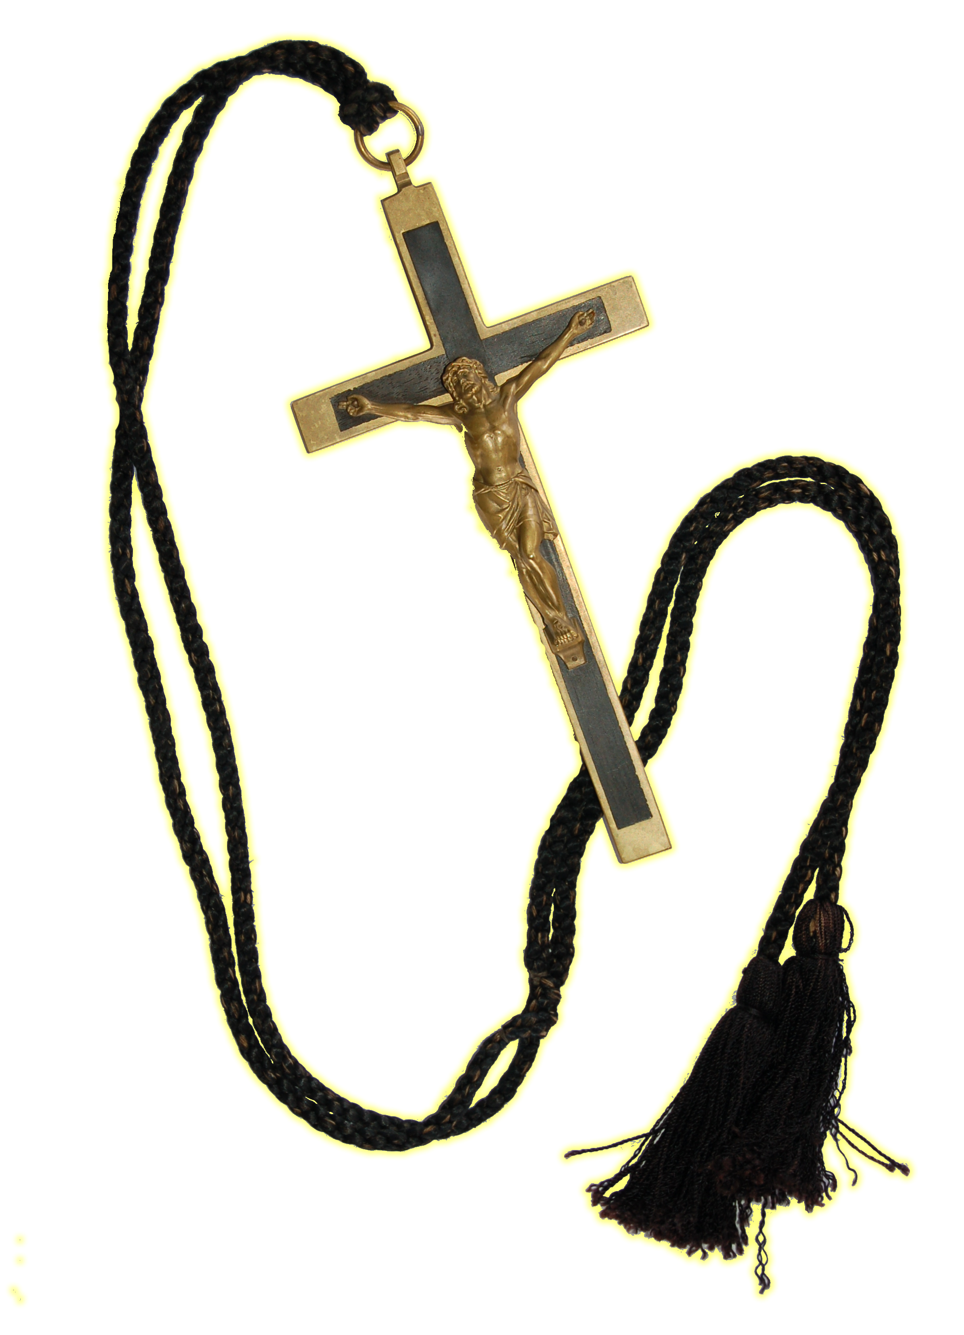

COLLEGE ANTHEM

SPIRIT OF MAZENOD

Mazenod a place of strength
Of courage and love for which we stand
Our strong foundations represent
The way we work hand in hand

Mazenod you’ve set us free
Loyalty always you deserve
This our motto ever be
Faith and country truly serve

Mazenod so let us pray
That we may always show our care
We thank God for his love today
This is our spirit this our prayer

The Key Values of
St Eugene de Mazenod

- To be aware of the dignity of all people.

- To be close to the people with whom we work and learn from them.

- To be committed to the Missionary and Prophetic Church.

- To “Leave nothing undared for the sake of the Kingdom”.

- To be people of passion for Christ and the Gospel.

- To strive for personal excellence.

- To hold high expectations of others.

- To take enough rest and be careful of our health.

Gladys Road, Lesmurdie
Western Australia 6076

Telephone: 9291 1500
Email: oblate@mazenod.wa.edu.au
Website: www.mazenod.wa.edu.au

